ITEC3250

Assignment 7

100 pts

Due 12/3

Dr. Jonathan Jenkins
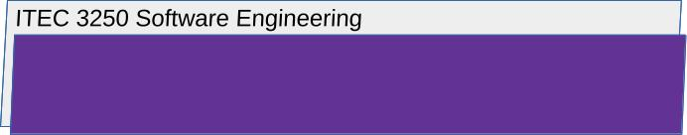

3.2 Software Resilience, with Textbook Chapter 14

- Select an information technology-based organization whose data or services are vulnerable to disruption

- Any university

  - Identify the assets of the business that need protection against adverse events
- A university has a range of data or services that are vulnerable to disruption. There are its physical assets, such as its infrastructure, equipment, and any art or historical collections it may hold. The university’s intellectual properties are also vulnerable. Any research data, patents or copyrights, or confidential information would fall under this category. The university needs to protect its faculty, staff and students against any adverse events as well. Any financial assets, such as donations, tuition, and grants must be protected from any potential theft. Finally, the university’s reputation needs to be protected. Any negative perception would harm the university.
  - Then, state and explain two resilience requirements you argue should be part of the software engineering work of the business
- I would argue that one resilience requirement should be fault tolerance. The software systems should be designed to tolerate any failures or errors without significant disruption. A second resilience requirement would be disaster recovery. The university should have a comprehensive disaster recovery plan that outlines the procedures for recovering from major disruptions like natural disasters or cyberattacks.
  - Finally, explain the organizational processes that you argue are needed to protect the assets of the business

What should the people who the business do to protect the assets of the system?

- Risk assessment and management – the university should have regular risk assessments to identify any potential threats or vulnerabilities. They should prioritize the risks based on their impact and likelihood of happening. Finally, they should develop and implement strategies to mitigate any identified risks.
- Security policies and procedures – The university should establish comprehensive security policies which outline the acceptable use of IT resources, data protection guidelines, and incident response procedures. There should be standard operating procedures in place, such as password management, system access, and data backup/recovery. Finally, there should be regular policy reviews that review and update policies and procedures to adapt to threats and technological advancements.
- Access control and identity management – The university should implement strong access controls that will limit access to sensitive systems and data. A robust identity and access management system should be implemented to authenticate and authorize users. Finally, the university should conduct regular reviews of user access privileges.
- Data protection and privacy – The university should classify its data based on sensitivity in order to determine appropriate security measures. Sensitive data should be encrypted both at rest and in transit. Regular backup/recovery procedures should be implemented. The university should make sure that they comply with any data privacy regulations.
- Incident response and recovery – There should be an incident response plan to address any security breaches or other IT incidents. The university should establish an incident response team that is responsible for coordinating the response. Regular testing should be conducted. The university should conduct post-incident reviews to identify what could be improved.
- Employee awareness and training – Faculty and staff should receive regular security awareness training and the university should conduct regular phishing simulations to test the staff’s ability to recognize and report suspicious emails.

3.3: Software Reuse, with Textbook Chapter 15
You may want to review the python tutorial material with regard to python functions and objects/classes
Also review carefully any python examples included with this assignment.
- Develop a brief python function unique to you and your own career goals, and then briefly explain two different ways that this function could be reused for two different purposes in a real application
- 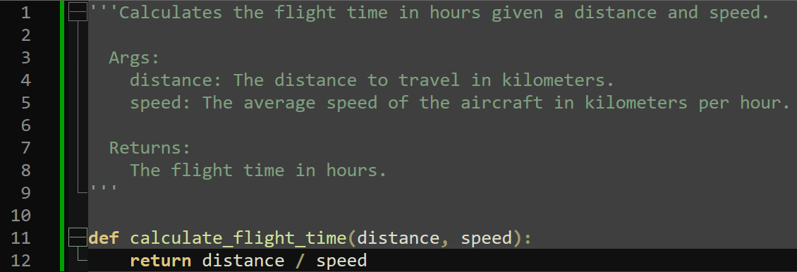

- This simple function can be used in several scenarios such as mission planning, training simulations, or logistics. It could be expanded upon to include wind speed and direction to help calculate the estimated flight time for a mission, to help calculate flight times or different aircraft and flight paths for training simulations, and it can help estimate the time required to transport supplies or personnel between destinations.

